Upon login, the user profile picture should reflect the logged in username
Upon creating a subadmin, you should have the possibility to add profile.
Ability to add subadmin’s company name when creating the subadmin user
Unable to upload user profile
Profile update page is also missing the cancel button.
Any change made on the settings page should be reflected on the reporting by date and percentage (rates).
Transaction limits should have the same behavior as above (it should include the date, )
Have a way to calculate the commissions over a period of time, be able to donate whole or portion of the commission for a given period
Plan for a flexible commission adjustment and calculation for multiple purposes in the future, for instance being able to dedicate portion or the whole commission to a given cause
Ability to handle multiple currencies by country, where BCTPay operates in the system
How many floating point do we take when calculating large amounts? What precision system will we use? .00 or .000, .0000???
- Have a footnote under each tab explaining what is the tab about, for example, under transaction limits we need to put a note to explain the tab.
- Correct the interface language to match the selected country, Guinea should change the interface to French text
- Adjust the settlement days per country as needed
When adding a role and subsequently trying to edit the permissions, there does not seem to be any permissions to add or remove. Permission list is empty.
KYCs requests page does not allow to approve or reject a request. Mission approve or reject buttons.
On the subadmin page there is no cancel button
When adding a subadmin, the default country name and code should be inserted by default (automatically)
On the subadmin edit/addition page, we should be able to have generate password functionality, add cancel button.
Role title (description) beside the role itself.
Business categories page should list only paging number if more items available beyond a page i.e 10, 25, 50, etc.
Navigating from business categories pagination back to countries for example displays the messge “No data available”
On the subadmin page, we can hide the phone number and the country columns to only the needed info.
Is it really important to have the numbering of the subadmin
- We need the ability to disable and enable subadmin
- Ability to either add business category name in locale language (English, French, etc.)
Move change password under user profile -> account
The cancel button does not work as expected.
Ability to impersonate a user.
Contextual error message shown in red should disappear once the field is filled with the correct value
KYC status field should also display on the customer profile page
Account status should also display on the customer profile page as read-only.
Move the account status setting to the customer addition/editing page if you have the appropriate permissions to edit it.
Remove the row numbering from the subadmin and customer pages
It is better to change customer account status on the customer profile page.
We get the following error when attempting to view the customer account page
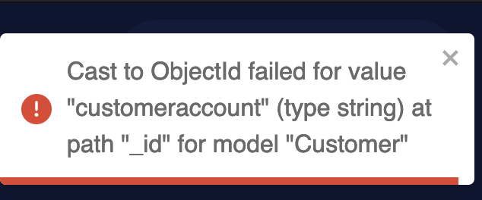
Can/will customer consume our APIs?
What is the relation between the KYC request and the customer?
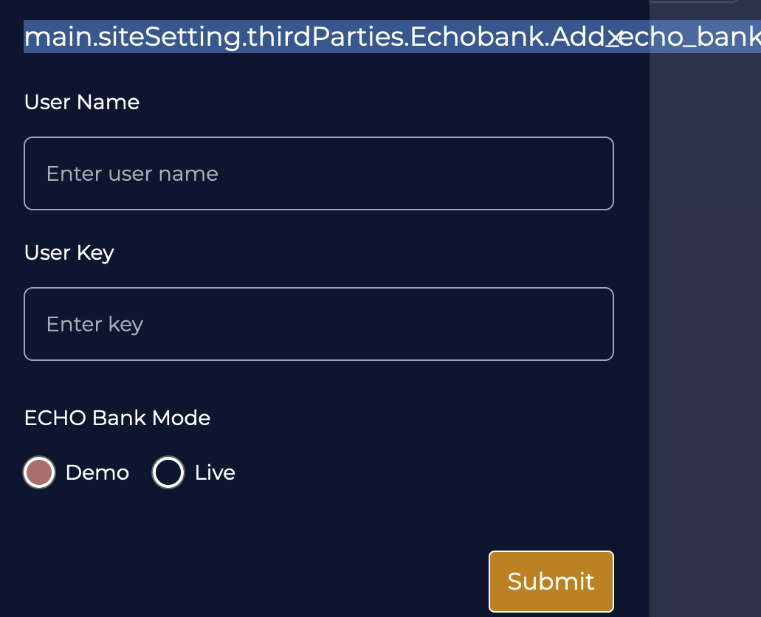

Separate the demo and live radio button options with two distinct rows.

